**Words of the week.**

Gordon/Quiet room

Week com… 21/01/19

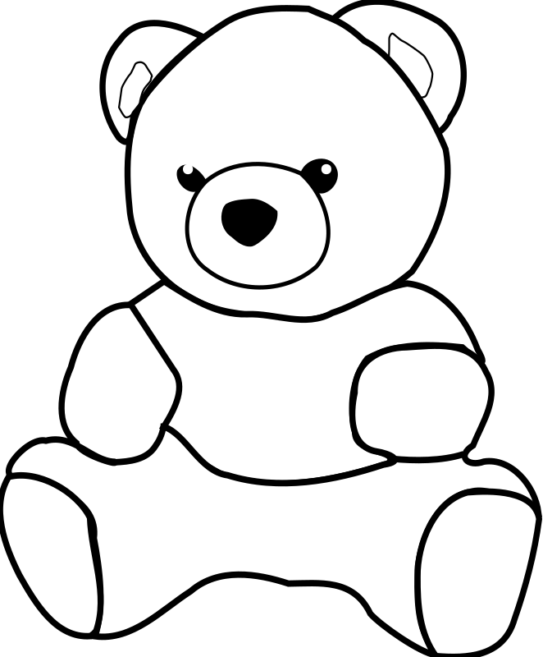

Pillow

Zzzzzz!

Chair

Snuggle

Cosy

