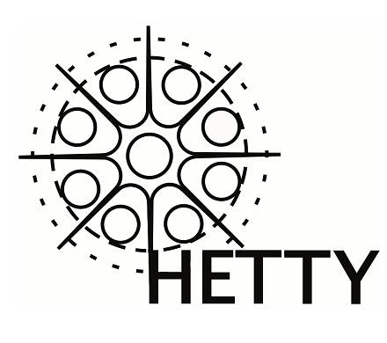
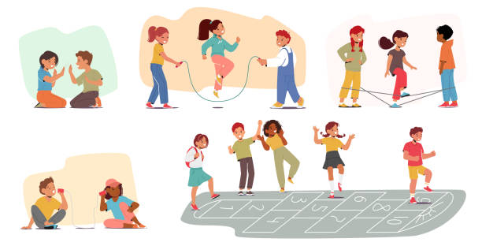
HETTY Breakfast and After School Club
Breakfast & after school club
Application form
Hoole Enterprise Trust Time for You (HETTY)
Hoole Lane, Hoole, Chester, CH2 3HB
www.hettypreschool.co.uk
Telephone: 07307 870845 or 01244 500908
Email: Denise - hettymanager@hooleceprimary.cheshire.sch.uk
Lucy – lucynevitte@hooleceprimary.cheshire.sch.uk
Website: www.hettypreschool.co.uk
HETTY MANAGER: Mrs Denise Bowes
DEPUTY MANAGER: Mrs Sue Noden
SUPERVISOR: Miss Lucy Nevitte

Date of form submitted:

Requested start date:
HETTY Breakfast and after school club is available five days a week, term time only. HETTY will close on all statutory bank holidays and for 2 weeks over the Christmas holidays.
Holiday care is available for School holiday dates and INSET days unless you are notified otherwise. Holiday care booking forms and registration forms are separate.
Session times
Breakfast Club - 7.45am to 8.45am, breakfast served up to 8.30am.
After school care - 3.10pm to 5.45pm, light snack served between 3.30 and 4.00pm.
Fees
‘Regular sessions’ are those that you are contracted to each week. ‘Ad-hoc’ sessions include extra bookings or changes to your contracted sessions. Ad-hoc bookings are charged at a higher rate due to the extra admin work involved in making changes to booking patterns.
Regular breakfast session £4.50 including breakfast cereal.
Ad-hoc breakfast session £5.50 including breakfast cereal.
Regular after school session £11.00 including a light snack.
Ad-hoc after school session £12.00 including a light snack.
A sibling discount of 5% will be applied for families with for more than one child who attends, discount is taken off the second child’s fees.
Full fees are payable for sessions missed through sickness, non-attendance, holidays or cancellations.
Cash, BACS, cheque, childcare vouchers, tax-free childcare and standing order can be used to make payments.
Valuables & lost property
Children must not wear or bring jewellery, toys or other valuable items into HETTY to avoid them getting lost or damaged. HETTY do not accept responsibility for lost, damaged or stolen items brought from home.
Attendance and bookings
If you wish to cancel your child’s place at HETTY or change your booking pattern, we require two weeks’ notice in writing or you will continue to be charged. All bookings must be made in advance with the Manager or Supervisor.
Policies and procedures
HETTY make all of our policies and procedures available for parents/carers to access on our website www.hettypreschool.co.uk

Child’s Details
First Name

Middle names
Surname
Preferred name (if different)
Gender |  |  | Male |  |  | Female
Child’s Date of birth (dd/mm/yyyy)
Child’s primary home address |  |  | Postcode:
Religion/Faith
Festivals/customs observed
Language spoken at home
I wish to register my child for (please tick):
 |  | Monday |  | Tuesday | Wednesday |  | Thursday | Friday
Breakfast club
After school club
Please detail the names of adults with legal guardianship of the named child
First name |  |  |  |  |  |  | Relationship to child
Surname
First name |  |  |  |  |  |  | Relationship to child
Surname
Page 1 of 6 – Wraparound care application
Parent/Carer details
Title |  | Miss, Mrs, Ms, Dr |  |  |  | Title |  | Miss, Mrs, Ms, Dr
First name |  |  |  |  |  | First name
Surname |  |  |  |  |  | Surname
Relationship to child |  |  |  |  |  | Relationship to child
Date of birth |  |  |  |  |  | Date of birth
Home address |  |  |  |  |  | Home address
Home telephone |  |  |  |  |  | Home telephone
Mobile telephone |  |  |  |  |  | Mobile telephone
Email address |  |  |  |  |  | Email address
Work address |  |  |  |  |  | Work address
Work telephone |  |  |  |  |  | Work telephone
Parent/Carer 1 |  |  | Please indicate which person will be the bill payer for HETTY nursery fees by ticking the relevant box. |  |  |  |  |  |  |  | Parent/Carer 2
Alternative contact details
Please provide details of at least one other person we can phone if we are unable to contact the primary caregiver
Name |  |  |  | Relationship to child |  |  |  |  |  | Mobile Number
Address |  |  |  |  |  |  | Other telephone number
Name |  |  |  | Relationship to child |  |  |  |  |  | Mobile number
Address  Page 2 of 6 – Wraparound care application |  |  |  |  |  |  | Other telephone number

Please list the details of any other adults who are permitted to collect your child from HETTY (other than those named above)
First name |  | Relationship to child
Surname |  | Relationship to child
First name |  | Relationship to child
Surname |  | Relationship to child
First name |  | Relationship to child
Surname |  | Relationship to child
First name |  | Relationship to child
Surname |  | Relationship to child
Child’s medical details
Name of child’s doctor |  | Address of doctors surgery  Telephone:
Please detail any special educational needs or disability that your child may have:
Please detail any medical needs including details of regular medication that your child may require:
Please detail any allergies or intolerances: *any allergy, not just food allergies*

*please also fill out a medical healthcare plan if your child suffers from allergies and medical conditions*
Please tell us about any dietary requirements:
Page 3 of 6 – Wraparound care application

Terms and conditions
- I understand that persistent late or non-payment of fees may jeopardise my child’s place.
- If my child is not collected by 5.45pm this will incur an extra charge to cover the costs of the two staff who are legally required to stay. If my child has still not been collected after doing everything possible to contact parents and emergency contacts, then I understand that the after-school club staff will be legally required to contact Social Care.
- I understand that persistent late collection may jeopardise my child’s place
- I understand that staff cannot be held responsible for any lost or stolen items.
- I understand that HETTY’s behaviour policy will apply to both the breakfast and after school clubs. HETTY is a time for fun, but my child should be aware of behaviour expectations. If my child chooses to misbehave, this could jeopardise my child’s place.
- I understand that HETTY will endeavour to cater for all children’s needs and make adaptations wherever possible, however in exceptional circumstances if the setting cannot meet my child’s needs, they may no longer able to attend the club
- I confirm that the information given on this form is correct and agree to notify the club of any changes in writing.
- I understand that the club has policies and procedures, there are expectations and obligations relating to the conduct of myself, and my child and I agree to abide by them. I understand that failure to do so will mean that my child will no longer be able to attend the club.
- I understand that my child will be provided with a snack and drink whilst at the club unless otherwise requested.
- Once my child is delivered/collected for breakfast/after school club he/she will be in the care of the staff until collected by a ‘named’ responsible adult. Please inform a member of staff if someone other than yourself is collecting your child.
- I will inform HETTY staff if my child will not be attending the club on a day that he/she is booked in to the club.
- I will pay promptly for sessions even when my child does not attend, unless other arrangements have been made with the manager, Mrs Bowes.
- I have been made aware of how to access the company’s policies and procedures and I understand that terms of my child attending the club are detailed in the settings policies.

I have read, understood and in signing this form and I accept the above terms and conditions for my child attending the breakfast/after school club.

Signature ……………………………………..……………………Print name………………………………………………..Date……………………….
Page 4 of 6 – Wraparound care application
Page 5 of 6 – Wraparound care application
Consent and permissions (1)

Photographs of Children
Occasionally we take photographs of the children during breakfast/afterschool club to show what we have been doing. Such photographs may be displayed inside the setting for display purposes, on our HETTY website or on promotional literature such as fliers or the local newspapers. Photographs will be stored on the system at HETTY for up to 6 years.

I give permission for the named child to:
- have their photograph taken to be used for display purposes within HETTY
- have their photograph taken to be used for publicity, e.g. Promotional literature, newsletter, website, newspapers

Activity permissions
As part of the activities that we offer, your child may be given the choice to have their face/nails painted and will be able to access technology such as iPad and laptop to access educational resources. Your children will also have supervised access to the school grounds with your consent

I give permission for the named child to:
- play in the school grounds with supervision
- be face painted/have nails painted
- access the internet through school iPad/laptop

Observations
If your child is part of the EYFS (reception school year) HETTY staff will observe and record your child’s success and achievements on their ‘Evidence me’ account. Achievements and next steps are discussed with your child’s class teacher regularly. Information we hold about your child is available to you upon request. Any observations of your child will be shared with parents weekly.

I give permission for the named child to:
- be observed by HETTY staff as part of the EYFS requirements via Evidence me
- take part in joint observations with peers which may include pictures or videos that are shared with other parents/carers in reception class

Signature……….……………………….Print name……………………….………………………………..Date…………………..
Page 6 of 6 – Wraparound care application
Consent and permissions (2)
Sharing information
We require your permission to share information about your child with their class teacher in order to support our partnership with Hoole C of E Primary school and to ensure the best outcomes for your child.

- I give permission for HETTY staff to share information about my child with staff at Hoole C of E primary school

Emergency first aid
In a medical emergency, HETTY staff may be required to seek urgent medical advice from your child’s doctor or may be required transport your child to hospital using their own vehicle. In the event of a serious accident, parent/carers will be contacted

- I give permission for HETTY to administer first aid if required
- I give permission for HETTY staff to seek medical advice should they feel it is necessary

Sun Cream
Sun cream should be applied by parents/carers before school. Your child will be encouraged to re-apply it again before outdoor play at after school club. Staff will assist your children in applying sun cream with your permission

- I give permission for HETTY staff to assist my child in applying their own sun cream
- I give permission for HETTY staff to apply Aldi own brand sun cream to my child (supplied by HETTY)

Medicines
If your child is unwell in our care HETTY staff will attempt to contact parent/carers before administering medicines.

- I give permission for HETTY staff to administer Calpol or alternative brand liquid paracetamol for children if my child requires it
- I give permission for HETTY staff to administer Piriton or alternative branded liquid antihistamine for children if my child requires it

Privacy policy and Data protection
Please see our privacy data protection policy on the HETTY website www.hettypreschool.co.uk for detailed information on what information we collect and how this information is used and stored.

- By ticking this box, you are consenting to us continuing to holding and processing your data and sending you information.

Signature……….……………………….Print name……………………….………………………………..Date…………………..

