**Word Plate**

Week commencing:

28/01/2019

Main Area

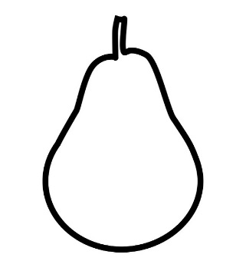[](https://www.google.co.uk/url?q=http://www.tocolor.pics/drawing-carrot-coloring-pages/&sa=U&ved=0ahUKEwjp5fahpeTaAhUJXMAKHT5oDyo4KBDBbgg8MBM&usg=AOvVaw0LKkGYYfNAQ5NPIBNflclw)

Scrumptious

Cutlery

**Container**

Tasty

Munch

